I3335 Project
Academic Year 2025-2026
Report

Team Composition
Project Title: PackerMan
Student Full Name: Patrick Farah
Student ID: 60388
Student Full Name: Charbel Fares
Student ID: 61116
Student Full Name: Bilal Hammoud
Student ID: 61105

Problem Description
PackerMan is a project that takes the iconic arcade game Pacman and give it a life of it’s own. By giving the player (Packer) and the Ghosts unique artificial algorithms, adding a numerous amount of extra Ghosts each with an individual personality (strategy to stop Packer), makes PackerMan a truly unique experience.
This topic was picked to help us push our limits in the most enjoyable, complex and interesting way possible, compared to other projects, this topic is the only one we think is the way to fully express and develop what we aim for.
To achieve this, we used multiple different algorithms, like Genetic Algorithm, A* Path finding and more. By giving each ghost a “moveset” (different behavior), we make each one of them unique and give Packer a challenge.

Methodology
Genetic Algorithm Implementation: Evolutionary Pacman
The core of this project is a Genetic Algorithm (GA), the mechanism facilitating Packer’s behavioral evolution. Unlike traditional machine learning, this system strictly emulates Darwinian principles to "solve" the game environment through successive generations.
1. Architectural Components:
The algorithm is built upon four primary pillars:
-DNA: An array representing a specific sequence of instructions or behavioral data.
-Gene Pool: A population of diverse specimens serving as the current generation's genetic reservoir.
-Selection: The "Natural Selection" barrier where specimens are chosen for reproduction based on performance.
-Mutation Rate: A low-probability variable introduced to maintain genetic variety.
-Note: A mutation rate that is too high transforms the GA into a stochastic brute-force search, undermining the efficiency of evolutionary convergence.
2. Fitness Logic vs. Brute Force:
While the game could theoretically be solved via brute force, the state space is too vast for such an approach to be computationally viable. Instead, we utilize a Fitness Function to assess the efficacy of each specimen during its lifecycle.
Points are awarded based on specific heuristics:
-Pellets Consumed: High reward.
-Survival Time: Incremental reward (lower priority than pellets).
-Win State: Maximum reward.
-Death: Significant penalty.
3. Selection Strategy and Diversity:
At the end of a generation, fitness scores are normalized to 1.0. We then utilize a probability-based selection (often called Roulette Wheel selection) where a specimen’s score dictates its likelihood of reproduction.
We explicitly avoid "Elitism" (selecting only the top performers) for two reasons:
Genetic Stagnation: Selecting only the top tier narrows the gene pool too quickly, leading to premature convergence on a sub-optimal solution.
Hidden Traits: Lower-scoring specimens may carry "nuggets of success"—specific genes that, when combined with others, contribute to a superior future specimen.
4. Crossover: The "Coin Flip" Approach:

The most critical aspect of evolution is the recombination of genes. Rather than a simple "Single-Point Crossover" (splitting the array in half), we employ a Uniform Crossover method, effectively a "coin flip" for every gene:
For each index in the DNA array, a random choice determines whether the gene is inherited from Parent A or Parent B. While computationally more intensive, this guarantees significantly higher genetic coverage and ensures that advantageous traits from both parents are more likely to be integrated into the offspring.
5. Iteration and Convergence:
The final, indispensable component of the GA is Repetition. Through the iterative cycle of evaluation, selection, and reproduction, the software refines the population's strategy. What would take a brute-force algorithm millennia to stumble upon is achieved through the focused, survival-based refinement of Darwinian emulation.
Ghost Functions:
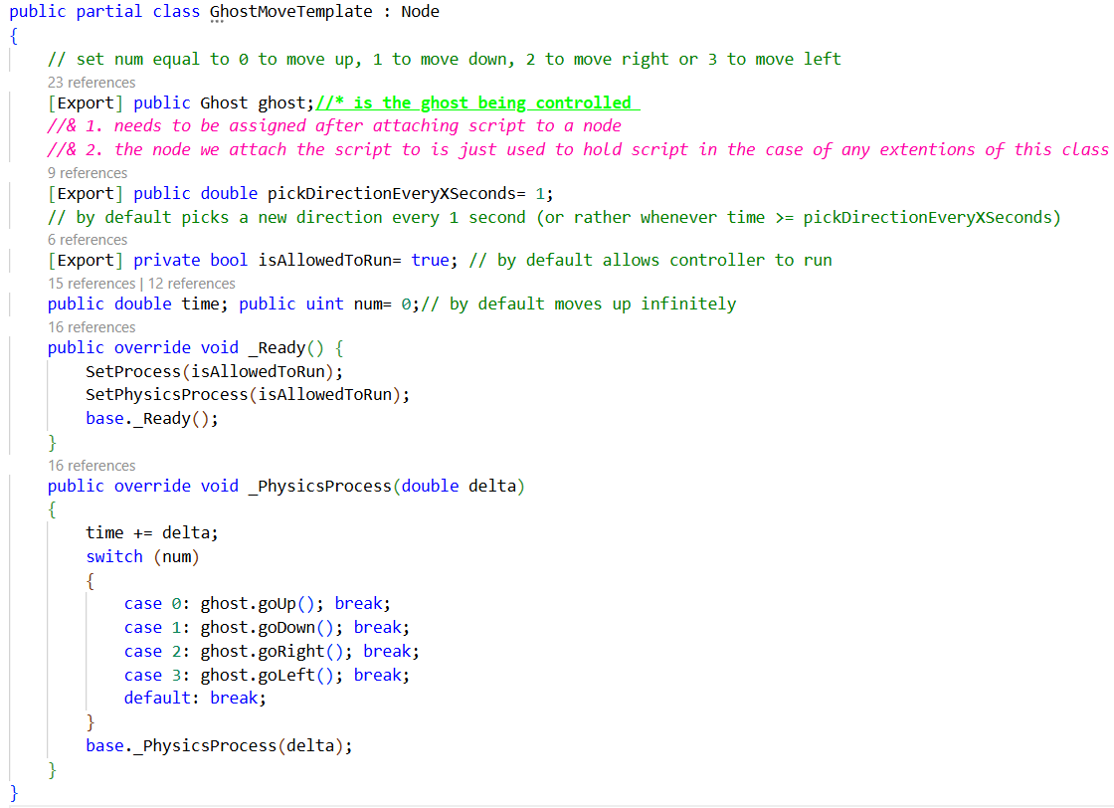a.1 the above is the full code used as an interface to control the assigned ghosts movement. It is intended to be extended.
this script handles incrementing time and changing directions based on the num variable, as well as enabling the controller to function via the isAllowedToRun flag.
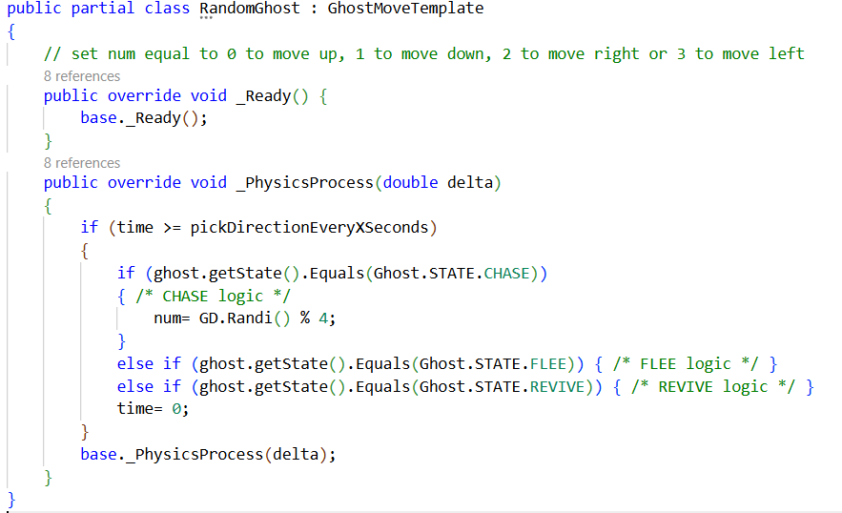b.1 the above script is the very first controller ever made a random ghost
the RandomGhost controller acts at once as a fully random direction picker and as a handy template to copy and paste to ensure the controller is running properly.
note: that a direction can only be picked when time is greater or equal to pickDirectionEveryXSeconds which is by default set to 1 (second) and that time is set to 0 if this condition if this condition is true, if this sequence is not respected then the ghost will execute its movement at everyy frame after a (very) minor delay dependent on how high a value pickDirectionEveryXSeconds is set to
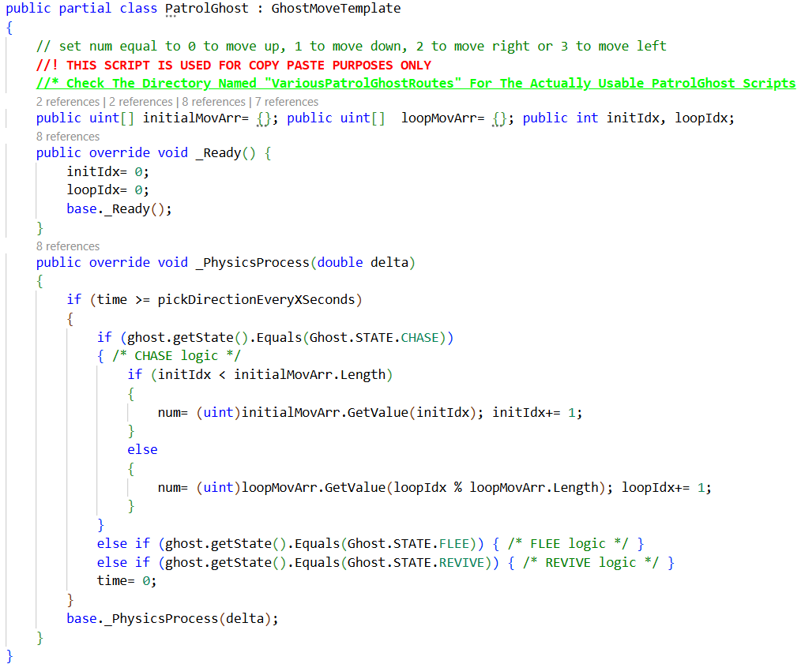c.1 the above is the script used as a blank template to creating a ghost that patrols along a path
initialMovArr is used to move the ghost toward the location considered to be the "patrol start".
mean while loopMovArr is where the patrol route is described.
the logic flow makes the ghost first moves under the instructions in initialMovArr until initIdx surpasses the number of directions specified in that array after which the ghost then moves under the instructions of loopMovArr based on loopIdx % loopMovArr.Length (the modulo is used to ensure movement loops)
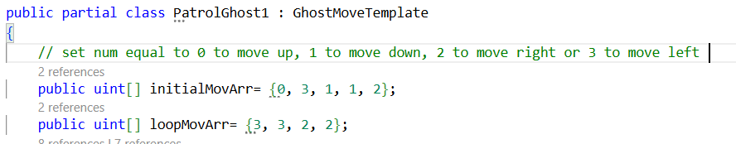c.2 the above is a short snippet of one of the "concrete" PatrolGhost copntrollers
it dictates that the ghost initially move up then left followed by down for 2 seconds and ending with moving right.
this sequences sets the ghost to end up where this script dictates as the "patrol start" where when reaching this position the controller then moves the ghost left and right for 2 seconds each infinitely.

Experimentations and Results
The student presents the algorithms used and the results obtained.

P.S. The use of AI tools (e.g., ChatGPT, DeepSeek, etc.) must be clearly acknowledged in your report. Such tools may be used for assistance, inspiration, or fixing grammar, but not for the full redaction of the report.

